IT tools for telework

How to use IT tools for telework

Computer requirements
The computer requirements for working from home are specified in the Regulations section.

Using a separate account on your computer
If you are working on a computer that you share with others, you need to set up your own account if you do not have one.

You can create a new user account in Windows 7 and 10 as described below.
Click on the Start button and select Control Panel > User accounts > Add or remove user accounts.
Click on Create new account and enter the name that you want to give it in the first box.
Select Administrator and click on Create Account.
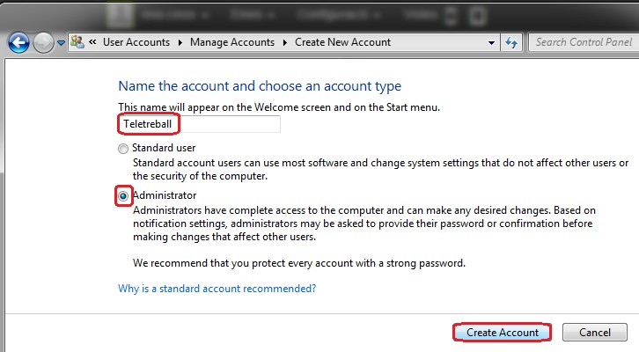
Select the account created and click on Create a password.
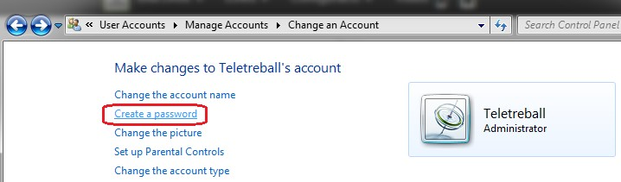
Then enter the password that you will use.
Click on the Start button, on Shut down and then on Switch user.

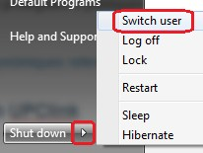

Verifying that your computer is up to date
You must keep your computer up to date with a supported operating system version (the minimum version supported by Microsoft is Windows 7) and the latest versions of system security patches and office software.

If your computer is running Windows, you can verify whether it is updated in Start > Control Panel > System and Security by clicking on Check for updates.
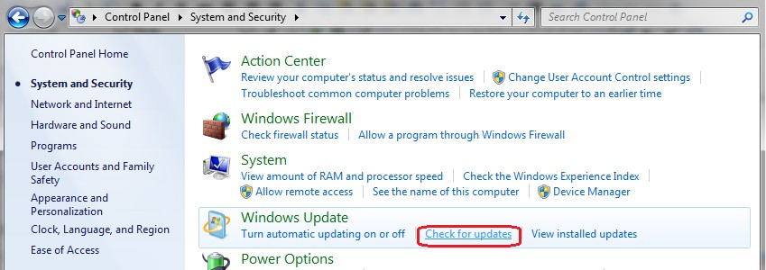

Computer security
Install and keep your antivirus software up to date with the latest versions. Consult the information by clicking on this link.

Internet connection security
If you are connected wirelessly, you need to use

a password-protected secure connection and to change your router’s default password.

Check your router’s documentation for instructions on changing the password.

The Internet User Security Office’s website offers recommendations on how to protect your Wi-Fi connection.

Secure connection to the UPC network
You need to work from home with a computer that deploys the same security measures as UPC computers. Any confidential data that you may use must not leave the UPC environment and must not be stored on your home computer. You must follow the instructions in the UPC Data Protection Manual , the UPC regulations and the terms of use set out in the legal notice on the UPC website.

If you use IT services that require working physically in the UPC network, services that you cannot access using a Wi-Fi connection (such as the UPC repository), you must establish a secure connection using UPClink.

If you use SAP or very specific software that is only installed on your UPC computer, you must establish a secure connection using UPClink and connect remotely to your UPC computer.
- Connecting to the UPC network via UPClink

You need to install software on your computer to use UPClink. See the installation instructions in the UPClink connection guide .
- Connecting to your UPC computer

Follow the instructions provided in the FAQ: How can I securely connect to my UPC computer from home?

Remember that you need to log in to UPClink before connecting to your UPC computer.

When you are teleworking, you can use the UPC telephone remotely. You have two options, although we recommend the first one, which makes better use of the University’s resources and hardly gets overloaded if heavily used, as in the current COVID-19 situation.

1. Using a softphone
It is a software that you can install on your computer or mobile phone to place and receive all calls just as if you were at the office. It is equivalent to having a desktop phone on your computer, mobile phone or tablet. It allows you to place and receive calls through your extension. Remember to start dialling 0 for external calls.

Click on the following link to see the instructions for installing and setting up a softphone according to your device.

Redirect your calls to a personal or University mobile phone, if you have one
Finally, as a less-recommended option, you can also divert your extension to an external phone, preferably a landline rather than a mobile phone. Follow the steps on this page: How to set up call forwarding.

Redirecting your phone to another phone
You can redirect your UPC phone to another phone with UPCconnect.

